Ideation Phase
Define the Problem Statements

Date | 31 January 2025
Team ID | SWTID-2026-9795
Project Name | Streamlining IT Procurement: Automating Standard Laptop Orders with Flow Designer
Maximum Marks | 2 Marks

Customer Problem Statement Template:
Create a problem statement to understand your customer's point of view. The Customer Problem Statement template helps you focus on what matters to create experiences people will love.
A well-articulated customer problem statement allows you and your team to find the ideal solution for the challenges your customers face. Throughout the process, you’ll also be able to empathize with your customers, which helps you better understand how they perceive your product or service.
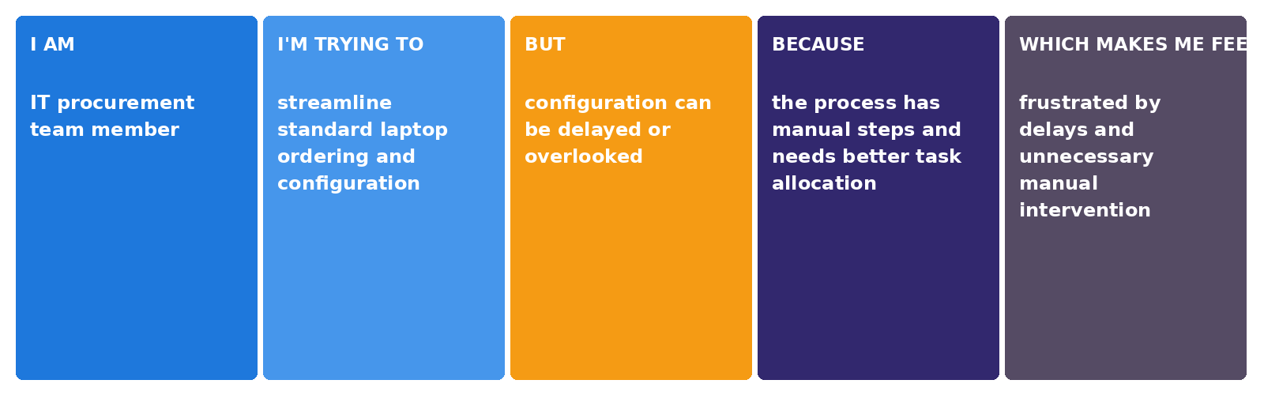
Reference: https://miro.com/templates/customer-problem-statement/
Example:

Problem Statement (PS) | I am (Customer) | I’m trying to | But | Because | Which makes me feel
PS-1 | IT procurement team member | streamline standard laptop ordering and configuration | configuration can be delayed or overlooked | the current process has manual steps and task allocation needs to be improved | frustrated by delays and manual intervention
PS-2 | user requesting a standard laptop | receive a laptop that is promptly configured after arrival | the configuration task may not be created and assigned in time | standard laptop procurement requires approval and manual handling | frustrated by longer wait times for a usable laptop

